Supplementary Material

Physical and mental health effects of repeated short walks in a blue space environment: a randomised crossover study

Cristina Vert, Mireia Gascon, Otavio Ranzani, Sandra Márquez, Margarita Triguero-Mas, Glòria Carrasco-Turigas, Lourdes Arjona, Sarah Koch, Maria Llopis, David Donaire-Gonzalez, Lewis R. Elliott, Mark Nieuwenhuijsen

Index
- Figure S1. Control site.
- Table S1. Detailed description of the environments of exposure
- Table S2. Description of the co-variables.
- Table S3. Assessment of the quality of the route (blue and the urban environments)
- Table S4. Association between environments of exposures and “WHO-5 well-being”, TMD, and vitality and mental health, stratified by “General health”.
- Table S5. Association between exposure and Total Well-being Score, stratified by gender.
- Table S6. Descriptive analysis of SBP (mmHg), DBP (mmHg), and Pulse rate (bpm) by exposure environments.
- Table S7. Association between exposure environments and blood pressure and pulse rate. Crude model.
- Table S8. Association between exposure environments and BP. Models adjusted by physical activity.
- Table S9. Descriptive analysis of physical activity levels quantitatively measured at T2, and during the whole study week.
- Table S10. Descriptive analysis of HRV variables by exposure environments.
- Table S11. Interactions p-values between exposure environment and study period. P-value of the likelihood ratio test comparing the model with and without the interaction term.
- Table S12. Association between exposure environments and logarithmic HRV variables. Crude model.
- Table S13. Association between exposure environments and logarithmic HRV variables. Models adjusted by physical activity.

Figure S1. Control site. Participants sit on the deckchair during 20 minutes per day the week they were randomly assigned to the control exposure (i.e. the study room). Photo taken by: Cristina Vert, October 2017.
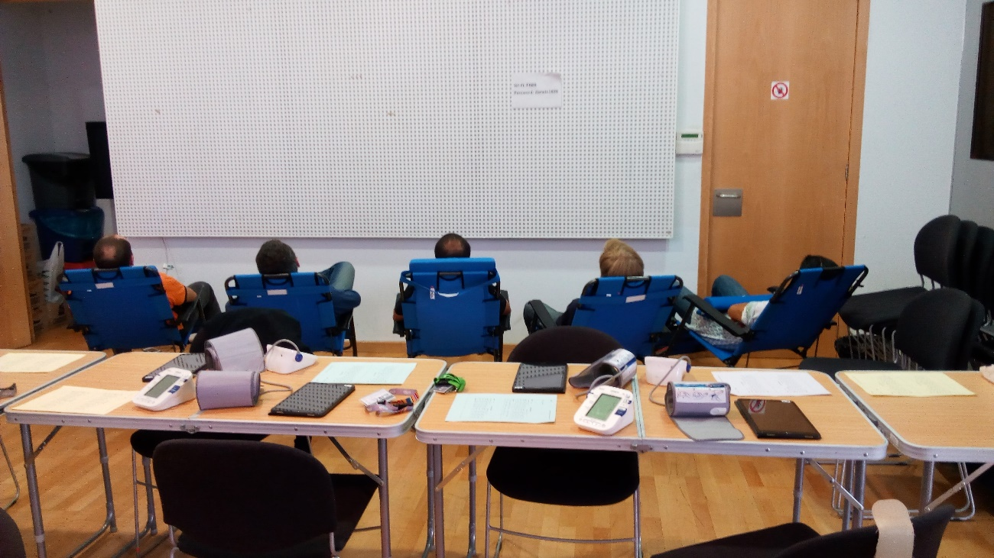
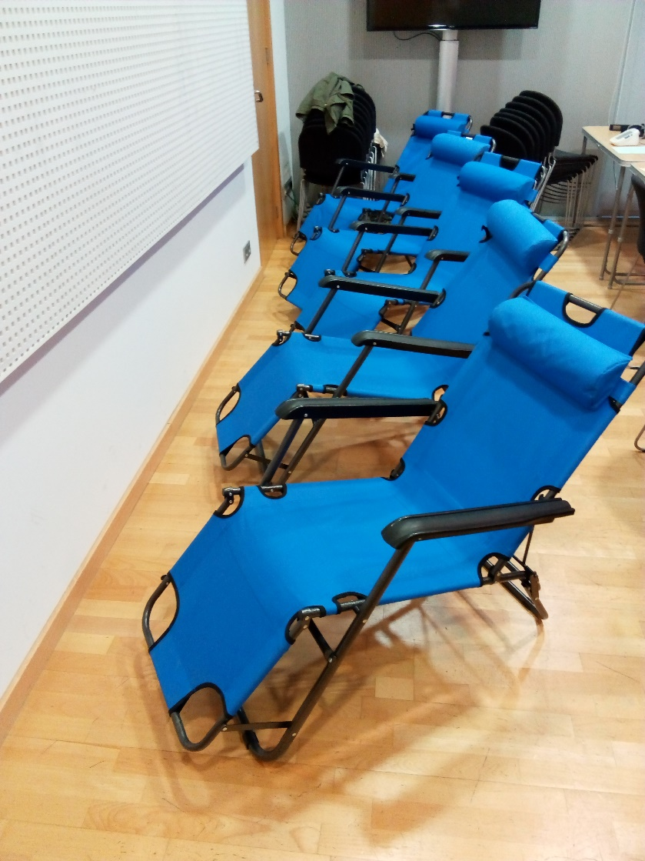
Table S1. Detailed description of the environments of exposure.
Exposure environments | Description
Blue Space | Participants walked from PRBB building (Carrer del Dr. Aiguader, 88, 08003 Barcelona) to the beach (Platja del Somorrostro) along the seaside walking path upstairs. In about 600 meters, they turned to the left and went downstairs to the breakwater called Espigó de Gas. Participants went back to study room following the same route. Route took 20 minutes.
Urban space | Participants walked from PRBB building (Carrer del Dr. Aiguader, 88, 08003 Barcelona) to go across an urban park (Parc de les Cascades), and turn to the left to walk along the sidewalk next to a road with a lane for buses and taxis, and another lane for other motorized vehicles (Carrer del Dr. Aiguader). In the sidewalk there is also a bicycle lane. Participants went back to the study room following the same route. Route took 20 minutes.
Control | Participants rested for 20 minutes in the study room, at PRBB, on comfortable deck chairs so they were able to relax. They were asked not to use their mobile phones, talk to each other, work or read. They were always supervised by at least one researcher.

Table S2. Description of the co-variables.
Variable | Description
Age* | Range from 19 to 49 years old.
Gender* | Women and men.
Education level* | Participants’ own educational level according to whether they had completed primary education, secondary education, or higher education.
Income level* | Participants’ own perception according to whether they felt comfortable or not regarding their household income.
Civil status* | Participants’ civil status
Residential access natural spaces* | Access to green and/or blue space within 10-15 minutes’ walk from participants’ home.
Views blue spaces at work* | Blue spaces views from either participants’ office, when commuting, and during lunch-time (labour days).
Residential access private open space* | Participants’ access to a private open space (e.g. terrace, garden, vegetable garden...).
Exposure blue spaces during childhood* | Participants’ usual exposure to blue spaces during childhood.
Meeting physical activity guidelines* | According to participants’ physical activity (PA) levels (measured in METs), compliance or not of WHO PA guidelines: WHO guidelines recommend to the adult population to do at least 150 minutes of moderate-intensity physical activity, or 75 minutes of vigorous-intensity physical activity throughout the week, or an equivalent combination of moderate- and vigorous-intensity activity (World Health Organization 2018).
Temperature | Average background temperature (ºC) for each study week. It was measures in the Zoo station (41.386261, 2.190526) by the Servei Meteorològic de Catalunya (Generalitat de Catalunya).
Relative humidity | Average background relative humidity (%) for each study week. It was measures in the Zoo station (41.386261, 2.190526) by the Servei Meteorològic de Catalunya (Generalitat de Catalunya).
BMI** | Body mass index assessed with the average height and weight measured at the beginning and the end of the study period.
Order | All the possible order of exposure to the different exposure environments (blue, urban, control).
Air pollution | Average NO₂ (mg/m³) and average O₃ (mg/m³) for each study week. It was measured in the Ciutadella station (41.3885, 2.1871) by Barcelona local authorities.
Season | Any of the two different study periods of 3 non-necessarily consecutive weeks each (1st period: April – May 2017; 2nd period: September – October 2017).
Turn | Any of the two different turns when participants could participate in the study: 1st turn (10.00am) or 2nd turn (11.30am).
Days of the week | Days of the study week, from Monday to Thursday. Some study weeks also included Friday as an exception. This occurred when a participant could not attend someday from Monday to Thursday, then he/she was rescheduled on Friday of the same week.
*These variables were collected with the Background questionnaire (T0).
**Mean BMI was calculated with the participants’ height and weight measured at T0 and again upon the completion of the study. It was measured in the study room by trained researchers.

Table S3. Assessment of the quality of the route, for the blue and the urban environments (N=59).
Assessment variables | Exposure
 | Blue | Urban | p-value*
Felt uncomfortable because of:
Air pollution (%) | 27 | 85 | <0.01
Noise (%) | 15 | 75 | <0.01
People (%) | 41 | 44 | <0.01
Quality of the route
Bad (%) | 0 | 29
Regular (%) | 7 | 40 | <0.01
Good (%) | 93 | 31
Felt satisfied walking along the route (%) | 95 | 40 | <0.01
Felt safe (i.e. no danger) walking along the route (%) | 95 | 74 | <0.01
There was no rubbish/vandalism along the route (%) | 79 | 62 | 0.04
*pvalues were estimated using chi-square or Fisher’s exact test.
Table S4. Association between environments of exposures (i.e. control, blue, urban) and “WHO-5 well-being”, TMD, and vitality and mental health, stratified by “General health” (good/not good)ª.
S4.1. Analysis scenario 1 (ref.=control).
 | General health = “Good” |  |  | General health = “Not good”
 | Control | Blue | Urban | Control | Blue | Urban
 | ref. | IRR^{b} (95% CI) | IRR^{b} (95% CI) | ref. | IRR^{b} (95% CI) | IRR^{b} (95% CI)
WHO-5 well-being
Total Well-being Score | ref. | 1.29 (1.23, 1.36)* | 0.97 (0.92, 1.02) | ref. | 1.62 (1.32, 1.99)* | 1.20 (0.95, 1.51)
Total Mood Disturbance (TMD)
Total score POMS | ref. | 0.95 (0.91, 0.99)* | 0.97 (0.93, 1.00) | ref. | 0.91 (0.81, 1.02) | 0.98 (0.87, 1.10)
Vitality and mental health (SF36)
Vitality | ref. | 1.07 (1.02, 1.12)* | 1.01 (0.96, 1.06) | ref. | 1.28 (1.09, 1.49)* | 1.06 (0.90, 1.26)
Mental health | ref. | 1.08 (1.03, 1.13)* | 1.03 (0.98, 1.07) | ref. | 1.05 (0.89, 1.25) | 0.94 (0.78, 1.14)

S4.2. Analysis scenario 2 (ref.=urban).
 | General health = “Good” |  | General health = “Not good”
 | Urban | Blue | Urban | Blue
 | ref. | IRR^{b} (95% CI) | ref. | IRR^{b} (95% CI)
WHO-5 well-being
Total Well-being Score | ref. | 1.34 (1.27, 1.41)* | ref. | 1.49 (1.17, 1.88)*
Total Mood Disturbance (TMD)
Total score POMS | ref. | 0.98 (0.94, 1.02) | ref. | 0.95 (0.82, 1.07)
Vitality and mental health (SF36)
Vitality | ref. | 1.06 (1.01, 1.11)* | ref. | 1.27 (1.04, 1.54)*
Mental health | ref. | 1.05 (1.00, 1.10)* | ref. | 1.17 (0.93, 1.45)
ªFor this analysis we only used “General health” assessed at T3 (and not at T1) because this is a trait measure and barely changed from T1 to T3.
Table S5. Association between exposure environments (i.e. control, blue, or urban space) and Total Well-being Score, stratified by gender (analysis scenario 1)^{a,b}
 | Exposure
 | Control | Blue |  | Urban
 | ref. | IRR (95% CI) |  | IRR (95% CI)
 |  | Women | Men | Women | Men
Positive quality-of-life currently
Total Well-being Score | ref. | 1.35 (1.27, 1.43)* | 1.25 (1.15, 1.37)* | 1.03 (0.97, 1.10) | 0.88 (0.80, 0.97)*
ªAnalysis scenario 2 is not shown because likelihood-ratio test did not indicate significant interaction for any variable for this analysis scenario.
^{b}Models were adjusted by age, and days of the week.

Table S6. Descriptive analysis of SBP (mmHg), DBP (mmHg), and Pulse rate (bpm) [median (IQR)] by exposure environments (i.e. control, blue and urban space).
 | Time period^{b} | Control | Difference T3-T1ª | Blue | Difference T3-T1 ª | Urban | Difference T3-T1 ª
SBP (mmHg)  [median (IQR)] | T1 | 97 (92.1, 106.5) | 0.4* | 99.5 (91.7, 105.8) | -0.6 | 99.1 (92.6, 105.3) | -1.3
 | T3 | 97.4 (91.7, 103.8) |  | 98.9 (91.2, 107.3) |  | 97.8 (92.1, 105.8)
DBP (mmHg)  [median (IQR)] | T1 | 65.1 (61.2, 70.0) | 0.2 | 65.6 (62.0, 71.0) | 0.8 | 65.1 (61.9, 71.3) | 1.1
 | T3 | 65.3 (61.3, 69.0) |  | 66.4 (62.2, 70.4) |  | 66.2 (61.9, 74.2)
Pulse rate (bpm)  [median (IQR)] | T1 | 66.2 (58.5, 71.9) | -2.1* | 67.2 (58.8, 73.9) | 0.5 | 66.3 (61.1, 74.2) | -0.7
 | T3 | 64.1 (57.9, 69.3) |  | 67.7 (59.4, 74.8) |  | 65.6 (60.8, 73.8)
Within each environment, we used the Wilcoxon signed rank sum test with Bonferroni-adjustment for multiple comparisons to assess whether the distribution of BP measured at T1 (ref. value) was significantly different (p-value ≤0.05*) than BP measured at T3.
ªDifference between T3 and T1 measurements of SBP, DBP, and pulse rate.
^{b}Time period refers to the moment when BP and pulse rate were measured. Time=1 (T1): pre-exposure; Time=3 (T3): post-exposure (see Figure 1).

Table S7. Association between exposure environments (i.e. control, blue, urban) and blood pressure and pulse rate. Crude model.
 | Analysis scenario 1 |  |  | Analysis scenario 2
 | Control | Blue | Urban | Urban | Blue
 |  | Coef. (95% CI) | Coef. (95% CI) |  | Coef. (95% CI)
SBP | ref. | 1.08 (1.19, 1.97)* | 1.11 (0.22, 2.00)* | ref. | -0.01 (-1.04, 1.02)
DBP | ref. | 0.26 (-0.28, 0.80) | 0.07 (-0.46, 0.61) | ref. | 0.20 (-0.32, 0.71)
Pulse rate | ref. | 2.06 (1.30, 2.81)* | 1.79 (1.04, 2.55)* | ref. | 0.28 (-0.38, 0.93)
Crude analysis (only adjusted by BP measured at T1)
*Statistically significant (p-value≤0.05)
SBP: Systolic blood pressure. DBP: Diastolic blood pressure

Table S8. Association between exposure environments (i.e. control, blue, urban) and BP (measured at T3)ª. BP variables included systolic blood pressure (SBP), diastolic blood pressure (DBP), and pulse rate. Models adjusted by physical activity [(A) Mean VM^{b} recorded at T2, i.e. during the exposure; and (B) Weekly mean VM^{b}].
 | Analysis scenario 1 |  |  | Analysis scenario 2
 | Control | Blue | Urban | Urban | Blue
 |  | Coef. (95% CI) | Coef. (95% CI) |  | Coef. (95% CI)
A) Adjusted by VM at T2
SBP | ref. | 1.41 (-0.32, 3.14) | 1.39 (-0.35, 3.14) | ref. | 0.04 (-0.74, 0.82)
DBP | ref. | -0.04 (-1.19, 1.11) | -0.33 (-1.48, 0.82) | ref. | 0.29 (-0.22, 0.80)
Pulse rate | ref. | 1.27 (-0.19, 2.72) | 0.90 (-0.56, 2.36) | ref. | 0.40 (-0.23, 1.02)
B) Adjusted by weekly VM
SBP | ref. | 1.12 (0.40, 1.84)* | 1.11 (0.37, 1.84)* | ref. | 0.02 (-0.75, 0.78)
DBP | ref. | 0.53 (0.05, 1.00) | 0.20 (-0.28, 0.69) | ref. | 0.30 (-0.18, 0.79)
Pulse rate | ref. | 2.20 (1.59, 2.80)* | 1.77 (1.16, 2.38)* | ref. | 0.39 (-0.23, 1.01)
ªModels adjusted by: age, gender, body mass index (BMI), the days of the week, blood pressure measured at T1, and physical activity (VM at T2, and weekly VM).
^{b}VM: vector magnitude.
*Statistically significant (p-value≤0.05)

Table S9. Descriptive analysis of physical activity levels [mean (sd)] quantitatively measured at T2, and during the whole study week.
Physical activity levels | Exposure environments |  |  | p-value
 | Control | Blue | Urban
VM at T2 (counts/min) | - | 941.48 (180.51) | 938.92 (177.98) | 0.90
Weekly VM (counts/min) | 518.99 (161.84) | 534.75 (173.19) | 523.05 (523.05) | 0.69
We used Kruskall Wallis test (with a statistically significant p-value≤0.05) to assess differences in the means of physical activity levels between exposure environments.
Table S10. Descriptive analysis of HRV variables [median (IQR)] by exposure environments (i.e. control, blue and urban space).
 | Time periodª | Control | Difference  T2-T1 and T3-T1 | Blue | Difference  T2-T1 and T3-T1 | Urban | Difference  T2-T1 and T3-T1
Frequency-domain
HR (bpm)  [median (IQR)] | T1 | 69.5 (61.3, 77.9) |  | 71.8 (63.8, 79.7) |  | 73.2 (65.2, 79.9)
 | T2 | 65.7 (58.2, 72.4) | -3.8* | 93.6 (85.8, 102.2) | 21.8* | 93.9 (83.2, 103.7) | 20.7*
 | T3 | 69.0 (60.8, 74.3) | -0.5* | 74.2 (66.3, 81.6) | 2.4 | 73.1 (64.7, 81.4) | -0.1
LF (ms²)  [median (IQR)] | T1 | 428.8 (226.4, 786.8) |  | 418.5 (261.2, 630.2) |  | 420.3 (229.5, 701.0)
 | T2 | 430.0 (270.6, 744.7) | -345.2 | 124.2 (72.4, 234.7) | -294.3* | 173.6 (80.2, 337.9) | -246.7*
 | T3 | 513.6 (320.8, 1026.5) | 84.8* | 411.0 (252.7, 676.0) | -7.5 | 443.2, 215.0, 621.7) | 22.9
HF (ms²)  [median (IQR)] | T1 | 180.0 (86.3, 383.6) |  | 187.4 (74.1, 350.7) |  | 177.6 (81.6, 371.7)
 | T2 | 231.2 (115.9, 586.2) | 51.2* | 31.9 (18.5, 73.0) | -155.5* | 50.0 (19.5, 100.4) | -127.6*
 | T3 | 217.9 (110.6, 474.3) | 37.9* | 159.9 (70.2, 301.0) | -27.5* | 145.9 (86.4, 353.9) | -31.7
LF/HF (%)  [median (IQR)] | T1 | 2.35 (1.7, 4.0) |  | 2.6 (1.8, 4.2) |  | 2.7 (2.1, 4.4)
 | T2 | 1.90 (1.3, 2.9) | -0.45* | 4.8 (3.4, 6.3) | 2.2* | 4.5 (3.1, 6.4) | 1.8*
 | T3 | 2.80 (1.8, 4.3) | 0,45 | 2.9 (2.0, 4.7) | 0.3* | 3.1 (1.9, 5.2) | 0.4*
Time-domain
SNDD (ms)  [median (IQR)] | T1 | 83.1 (67.6, 105.7) |  | 88.6 (68.2, 106.6) |  | 91.8 (70.6, 106.2)
 | T2 | 93.8 (73.4, 122.7) | 10,7* | 57.9 (46.3, 74.3) | -30.7* | 62.1 (47.8, 85.3) | -29.7*
 | T3 | 92.1 (73.5, 114.7) | 9* | 90.4 (74.1, 115.9) | 1.8 | 92.2 (73.8, 118.3) | 0.4
RMSSD (ms)  [median (IQR)] | T1 | 45.9 (29.5, 64.0) |  | 43.5 (29.1, 59.3) |  | 44.1 (28.8, 60.6)
 | T2 | 53.1 (35.6, 82.5) | 7.2* | 23.9 (15.9, 35.1) | -19.6* | 27.7 (17.1, 44.6) | -16.4*
 | T3 | 47.4 (33.5, 71.0) | 1.5* | 39.5 (30.4, 50.9) | -4* | 41.5 (28.5, 55.4) | -2.6
Within each environment, we used the Wilcoxon signed rank sum test with Bonferroni-adjustment for multiple comparisons to assess whether the distribution of HRV variables measured at T1 (ref. value) was significantly different (p-value ≤0.05*) than for HRV variables measured at T2 and measured at T3.
ªTime period refers to the moment when the HRV parameters were measured. Time=1 (T1): pre-exposure; Time=2 (T2): during exposure; Time=3 (T3): post-exposure (see Figure 1)

Table S11. Interactions p-values between exposure environment and study period. P-value of the likelihood ratio test comparing the model with and without the interaction term.
HRV parameters | p-value
 | Analysis scenario 1 | Analysis scenario 2
HR | <0.001 | 0.993
LF | <0.001 | 0.023
HF | <0.001 | 0.031
LF/HF | <0.001 | 0.265
SDNN | <0.001 | 0.371
RMSSD | <0.001 | 0.225

Table S12. Association between exposure environments (i.e. control, blue, urban) and logarithmic HRV variables. HRV variables included (i) frequency domain measurements: heart rate (HR), low frequency power (LF), high frequency power (HF), and the ratio of LF to HF (LF/HF); and (ii) time domain measurements: standard deviation of NN interval (SDNN), and the root mean square of successive NN interval differences (RMSSD). Crude model.
 |  | Analysis scenario 1 |  |  | Analysis scenario 2
 |  | Control | Blue | Urban | Urban | Blue
 | Time periodª |  | Coef. (95% CI) | Coef. (95% CI) |  | Coef. (95% CI)
Ln(HR) | T1 | ref. | 0.019 (0.003, 0.034)* | 0.022 (0.007, 0.038)* | ref. | -0.002 (-0.018, 0.014)
 | T2 | ref. | 0.360 (0.345, 0.376)* | 0.366 (0.350, 0.381)* | ref. | -0.004 (-0.020, 0.012)
 | T3 | ref. | 0.069 (0.054, 0.084)* | 0.074 (0.059, 0.090)* | ref. | -0.004 (-0.020, 0.013)
Ln(LF) | T1 | ref. | 0.001 (-0.100, 0.102) | 0.009 (-0.093, 0.111) | ref. | -0.017 (-0.126, 0.092)
 | T2 | ref. | -1.373 (-1.475, 1.272)* | -1.191 (-1.293, -1.089)* | ref. | -0.191 (-0.301, -0.082)*
 | T3 | ref. | -0.304 (-0.406, -0.203)* | -0.337 (-0.439, -0.235)* | ref. | 0.024 (-0.086, 0.133)
Ln(HF) | T1 | ref. | -0.038 (-0.166, 0.089) | -0.046 (-0.174, 0.083) | ref. | -0.004 (-0.142, 0.134)
 | T2 | ref. | -2.257 (-2.385, -2.130)* | -2.023 (-2.150, -1.893)* | ref. | -0.247 (-0.385, -0.109)*
 | T3 | ref. | -0.411 (-0.539, -0.284)* | -0.416 (-0.545, -0.287)* | ref. | -0.007 (-0.145, 0.131)
Ln(LF/HF) | T1 | ref. | 0.047 (-0.039, 0.133) | 0.062 (-0.025, 0.149) | ref. | -0.013 (-0.105, 0.078)
 | T2 | ref. | 0.976 (0.890, 1.062)* | 0.886 (0.799, 0.973)* | ref. | 0.092 (0.000, 0.184)*
 | T3 | ref. | 0.113 (0.027, 0.199)* | 0.084 (-0.003, 0.171)* | ref. | 0.031 (-0.061, 0.122)
Ln(SDNN) | T1 | ref. | -0.045 (-0.006, 0.097) | 0.066 (0.014, 0.119)* | ref. | -0.026 (-0.082, 0.031)
 | T2 | ref. | -0.534 (-0.585, -0.482)* | -0.469 (-0.522, -0.417)* | ref. | -0.069 (-0.125, -0.013)*
 | T3 | ref. | 0.001 (-0.050, 0.053) | 0.003 (-0.049, 0.055) |  | -0.006 (-0.062, 0.051)
Ln(RMSSD) | T1 | ref. | -0.021 (-0.091, 0.049) | -0.032 (-0.102, 0.039) | ref. | 0.003 (-0.074, 0.080)
 | T2 | ref. | -0.920 (-0.990, -0.850)* | -0.819 (-0.890, -0.748)* | ref. | -0.108 (-0.185, -0.031)*
 | T3 | ref. | -0.255 (-0.325, -0.185)* | -0.227 (-0.297, -0.156)* | ref. | -0.036 (-0.113, 0.041)
ªTime period refers to the moment when the HRV parameters were measured. Time=1 (T1): pre-exposure; Time=2 (T2): during exposure; Time=3 (T3): post-exposure (see Figure 1)
*Statistically significant (p-value≤0.05)

Table S13. Association between exposure environments (i.e. control, blue, urban), and logarithmic HRV variables. HRV variables included (i) frequency domain measurements: heart rate (HR), low frequency power (LF), high frequency power (HF), and the ratio of LF to HF (LF/HF); and (ii) time domain measurements: standard deviation of NN interval (SDNN), and the root mean square of successive NN interval differences (RMSSD). Models adjusted by physical activity [(A) Mean VM^{b} recorded at T2, i.e. during the exposure; and (B) Weekly mean VM^{b}].
 |  | Analysis scenario 1 |  |  | Analysis scenario 2
 |  | Control | Blue | Urban | Urban | Blue
 | Time periodª |  | Coef. (95% CI) | Coef. (95% CI) |  | Coef. (95% CI)
A) Adjusted by VM at T2
Ln(HR) | T1 | ref. | 0.021 (0.005, 0.036)* | 0.026 (0.010, 0.041)* | ref. | -0.005 (-0.021, 0.012)
 | T2 | ref. | 0.306 (0.270, 0.342)* | 0.308 (0.271, 0.344)* | ref. | -0.003 (-0.020, 0.015)
 | T3 | ref. | 0.072 (0.056, 0.087)* | 0.077 (0.062, 0.093)* | ref. | -0.005 (-0.022, 0.011)
Ln(LF) | T1 | ref. | -0.004 (-0.102, 0.095) | -0.006 (-0.105, 0.093) | ref. | -0.001 (-0.107, 0.104)
 | T2 | ref. | -0.905 (-1.132, -0.679)* | -0.731 (-0.961, -0.501)* | ref. | -0.177 (-0.288, -0.067)*
 | T3 | ref. | -0.290 (-0.388, 0.191)* | -0.339 (-0.438, -0.240)* | ref. | 0.045 (-0.059, 0.150)
Ln(HF) | T1 | ref. | -0.038 (-0.162, 0.087) | -0.054 (-0.179, 0.071) | ref. | 0.012 (-0.120, 0.144)
 | T2 | ref. | -1.494 (-1.780, -1.207)* | -1.271 (-1.561, -0.980)* | ref. | -0.224 (-0.364, -0.085)*
 | T3 | ref. | -0.406 (-0.531, -0.282)* | -0.422 (-0.547, -0.297)* | ref. | 0.011 (-0.121, 0.143)
Ln(LF/HF) | T1 | ref. | 0.042 (-0.045, 0.128) | 0.056 (-0.0.31, 0.142) | ref. | -0.015 (-0.106, 0.077)
 | T2 | ref. | 0.644 (0.446, 0.842)* | 0.550 (0.348, 0.751)* | ref. | 0.092 (-0.005, 0.188)
 | T3 | ref. | 0.122 (0.0.036, 0.208)* | 0.088 (0.001, 0.174) | ref. | 0.034 (-0.058, 0.125)
Ln(SDNN) | T1 | ref. | 0.045 (-0.006, 0.096) | 0.065 (0.014, 0.117)* | ref. | -0.023 (-0.078, 0.032)
 | T2 | ref. | -0.325 (-0.441, -0.207)* | -0.244 (-0.363, -0.125)* | ref. | -0.078 (-0.136, -0.020)*
 | T3 | ref. | -0.004 (-0.047, 0.055) | 0.002 (-0.049, 0.0537) |  | -0.000 (-0.055, 0.054)
Ln(RMSSD) | T1 | ref. | -0.024 (-0.092, 0.044) | -0.037 (-0.105, 0.032) | ref. | 0.009 (-0.064, 0.082)
 | T2 | ref. | -0.532 (-0.689, -0.376)* | -0.443 (-0.601, -0.284)* | ref. | -0.088 (-1.165, -0.011)*
 | T3 | ref. | -0.255 (-0.322, -0.187)* | -0.230 (-0.299, -0.162)* | ref. | -0.028 (-0.101, 0.045)
B) Adjusted by weekly VM
Ln(HR) | T1 | ref. | 0.017 (0.001, 0.033)* | 0.017 (0.001, 0.034)* | ref. | -0.001 (-0.019, 0.016)
 | T2 | ref. | 0.367 (0.351, 0.383)* | 0.369 (0.353, 0.386)* | ref. | -0.004 (-0.021, 0.013)
 | T3 | ref. | 0.073 (0.057, 0.089)* | 0.073 (0.057, 0.090)* | ref. | -0.001 (-0.019, 0.016)
Ln(LF) | T1 | ref. | 0.002 (-0.102, 0.107) | 0.014 (-0.093, 0.122) | ref. | -0.013 (-0.127, 0.100)
 | T2 | ref. | -1.396 (-1.501, -1.291)* | -1.193 (-1.301, -1.086)* | ref. | -0.203 (-0.317, -0.090)*
 | T3 | ref. | -0.303 (-0.408, -0.198)* | -0.340 (-0.448, -0.232)* | ref. | 0.036 (-0.078, 0.150)
Ln(HF) | T1 | ref. | -0.030 (-0.161, 0.102) | -0.028 (-0.163, 0.107) | ref. | -0.002 (-0.143, 0.139)
 | T2 | ref. | -2.29 (-2.425, -2.161)* | -2.047 (-2.182, -1.912)* | ref. | -0.247 (-0.388, -0.105)*
 | T3 | ref. | -0.417 (-0.549, -0.285)* | -0.405 (-0.540, -0.270)* | ref. | -0.012 (-0.154, 0.129)
Ln(LF/HF) | T1 | ref. | 0.040 (-0.050, 0.130) | 0.049 (-0.043, 0.141) | ref. | -0.010 (-0.105, 0.086)
 | T2 | ref. | 0.995 (0.905, 1.084)* | 0.907 (0.815, 0.999)* | ref. | 0.087 (-0.008, 0.183)
 | T3 | ref. | 0.118 (0.028, 0.208)* | 0.071 (-0.022, 0.163) | ref. | 0.047 (-0.049, 0.142)
Ln(SDNN) | T1 | ref. | 0.044 (-0.010, 0.097) | 0.073 (0.018, 0.127)* | ref. | -0.025 (-0.083, 0.033)
 | T2 | ref. | -0.543 (-0.597, -0.490)* | -0.461 (-0.516, -0.407)* | ref. | -0.078 (-0.136, -0.020)*
 | T3 | ref. | -0.012 (-0.065, 0.041) | 0.012 (-0.042, 0.067) |  | -0.021 (-0.079, 0.038)
Ln(RMSSD) | T1 | ref. | -0.020 (-0.092, 0.051) | -0.020 (-0.094, 0.054) | ref. | 0.002 (-0.077, 0.080)
 | T2 | ref. | -0.937 (-1.001, -0.865)* | -0.829 (-0.903, -0.756)* | ref. | -0.106 (-1.185, -0.027)*
 | T3 | ref. | -0.267 (-0.339, -0.195)* | -0.226 (-0.300, -0.152)* | ref. | -0.039 (-0.117, 0.040)
ªTime period refers to the moment when the HRV parameters were measured. Time=1 (T1): pre-exposure; Time=2 (T2): during exposure; Time=3 (T3): post-exposure (see Figure 1)
^{b}VM: vector magnitude
Models adjusted by: age, gender, body mass index (BMI), days of the week (see Table S2 – Supplementary Material), and physical activity levels.
*Statistically significant (p-value≤0.05)

