Supplementary Materials

Supplementary Table 1. Results of likelihood ratio tests comparing the fit of generalised additive mixed models which included a random intercept of country and a fixed slope of residential distance, with those which additionally included a random slope of residential distance.
 | Residual degrees of freedom | Residual deviance | Degrees of freedom | Deviance | p value | AIC
Coasts
Model without a random slope | 15189 | 13529 | - | - | - | 13985.77
Model with a random slope | 15173 | 13347 | 15.54 | 182.25 | >0.001 | 13817.45
Lakes
Model without a random slope | 12196 | 7877 | - | - | - | 12717.82
Model with a random slope | 12186 | 7852 | 10.37 | 25.20 | 0.006 | 12692.87
Rivers
Model without a random slope | 12235 | 12446 | - | - | - | 8067.78
Model with a random slope | 12223 | 12404 | 11.93 | 41.77 | >0.001 | 8055.82
N.B Models apply survey weights. As random effect terms have a zero-dimensional null space (i.e. they can be penalised to zero), p value approximation can be poor for these generalised likelihood ratio tests; the value can often be substantially too low. Nonetheless, in all three cases better fit is still indicated by the lower AIC values.

Supplementary Table 2. Results of initial generalised additive mixed models predicting the probability of visiting each environment for recreation at least weekly in the last four weeks from an unknown smooth function of residential distance to each environment (modelled with thin-plate regression splines).
 | Effective degrees of freedom | Chi-squared test
Coasts
Distance | 8.58 | ***392.98
Tjur’s R² | 0.16
Country/territory-level variance | 0.35
Distance variance | 0.00
Lakes
Distance | 7.01 | ***134.75
Tjur’s R² | 0.04
Country/territory-level variance | 0.23
Distance variance | 0.00
Rivers
Distance | 4.24 | ***43.66
Tjur’s R² | 0.04
Country/territory-level variance | 0.16
Distance variance | 0.02
N.B Models apply survey weights and include a random intercept of country/territory and random slopes of residential distance to each environment. Tjur’s R² represents the difference between the averages of fitted values for successes (i.e. visited in the last week) and failures (i.e. did not visit in the last week), respectively (Tjur, T., 2009. Coefficients of Determination in Logistic Regression Models—A New Proposal: The Coefficient of Discrimination. The American Statistician 63, 366–372. https://doi.org/10.1198/tast.2009.08210). *** p<.001

Supplementary Table 3. Numbers of respondents per country/territory who reside within the various distance categorisations created for each type of bluespace.
 | Coasts |  |  |  |  |  | Lakes |  |  |  | Rivers
 | 0-1km | >1-5km | >5-25km | >25-50km | >50km |  | 0-1km | >1-5km1 | >5km |  | 0-1km | >1-2.5km | >2.5km
Bulgaria | 29 | 75 | 25 | 20 | 801 |  | 58 | 296 | 595 |  | 630 | 277 | 42
California, US | 31 | 127 | 291 | 100 | 301 |  | - | - | - |  | - | - | -
Canada | 32 | 42 | 52 | 10 | 631 |  | - | - | - |  | - | - | -
Czech Republic | 0 | 0 | 0 | 0 | 949 |  | 59 | 371 | 519 |  | 652 | 275 | 22
Estonia | 94 | 216 | 144 | 50 | 313 |  | 71 | 295 | 451 |  | 444 | 287 | 86
Finland | 171 | 158 | 104 | 54 | 401 |  | 306 | 291 | 290 |  | 452 | 261 | 174
France | 39 | 59 | 97 | 77 | 653 |  | 51 | 278 | 593 |  | 523 | 313 | 86
Germany | 11 | 19 | 42 | 17 | 771 |  | 69 | 273 | 517 |  | 509 | 248 | 102
Greece | 205 | 236 | 245 | 38 | 48 |  | 24 | 25 | 722 |  | 450 | 261 | 60
Hong Kong, CN | 326 | 206 | 22 | 1 | 1 |  | - | - | - |  | - | - | -
Ireland | 134 | 277 | 264 | 105 | 92 |  | 55 | 213 | 604 |  | 531 | 261 | 80
Italy | 132 | 117 | 184 | 82 | 293 |  | 39 | 100 | 669 |  | 506 | 233 | 69
Netherlands | 28 | 156 | 376 | 181 | 199 |  | 146 | 516 | 278 |  | 249 | 214 | 477
Portugal | 117 | 249 | 228 | 101 | 91 |  | 18 | 82 | 673 |  | 387 | 287 | 112
Queensland, AU | 87 | 128 | 322 | 84 | 157 |  | - | - | - |  | - | - | -
Spain | 108 | 148 | 97 | 51 | 338 |  | 35 | 98 | 585 |  | 407 | 240 | 94
Sweden | 150 | 206 | 218 | 75 | 205 |  | 262 | 345 | 247 |  | 412 | 281 | 161
United Kingdom | 117 | 164 | 276 | 276 | 269 |  | 41 | 402 | 657 |  | 521 | 391 | 188

Supplementary Figure 1. Predicted probabilities of visiting the coast, lakes, or rivers at least weekly in the last four weeks as a function of residential distance, derived from our generalised additive mixed models. These are the same relationships that are depicted in Figure 3 of the main manuscript, but including the entire spectrum of distances in the data. The curved lines represent the main spline term and the shaded areas represent the 95% confidence interval.
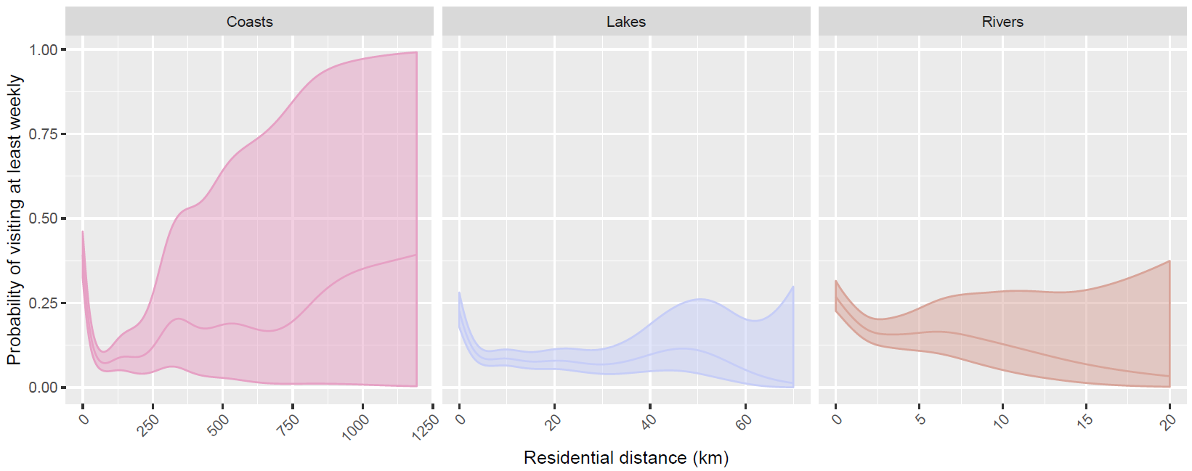

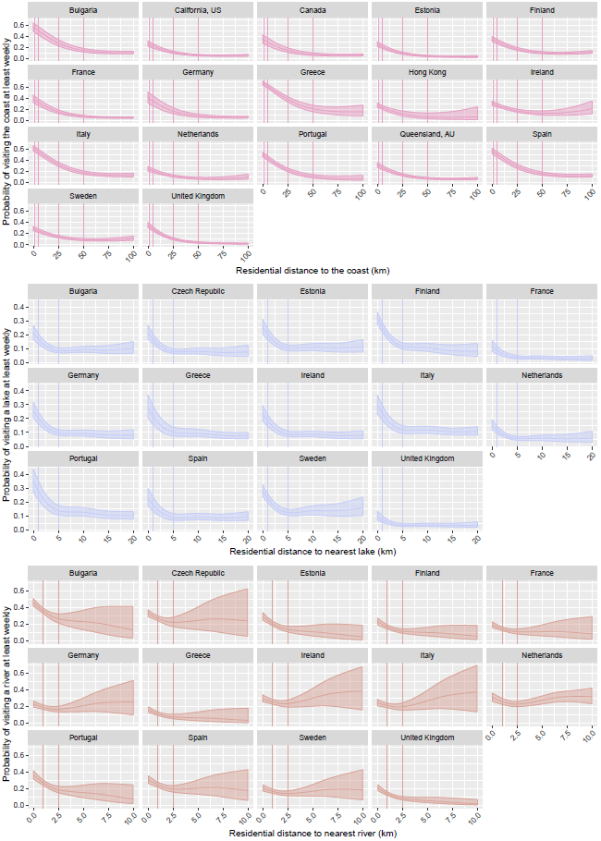
Supplementary Figure 2. Country/territory-level distance-decay effects derived from the random effect components of our generalised additive mixed models. The curved lines represent the main spline term and the shaded areas represent the 95% confidence interval. Note the Czech Republic is omitted from the residential coastal distance plot (top) as all participants resided over 50km from the nearest coastline.

